**Alekhya Krishna Balivada Python Day 6 Assessment-6(18-12-2023)**

**OOPS:** Object Oriented Programming

**Class:** A class is a code template for creating object.

**Object:** Instance of class.

**__init__:** It is always executed when the class is being executed.

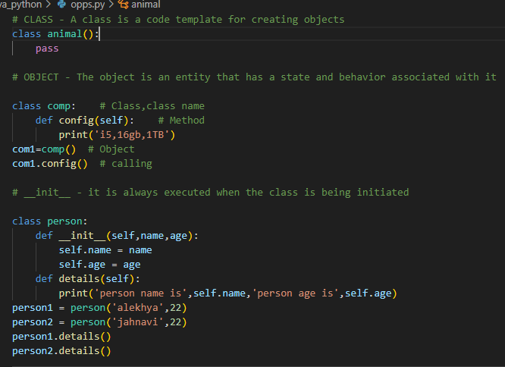

**Inheritance:** It allows us to define a class that inherits from another class.

**Types of inheritance**: 1. Single Inheritance

2. Multi-level Inheritance

3. Multiple Inheritance

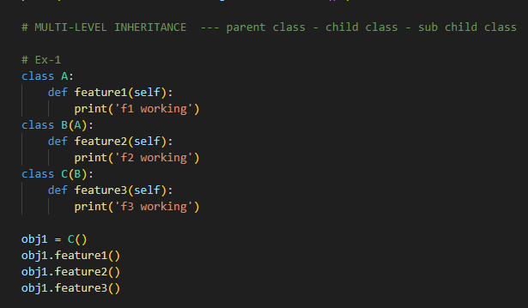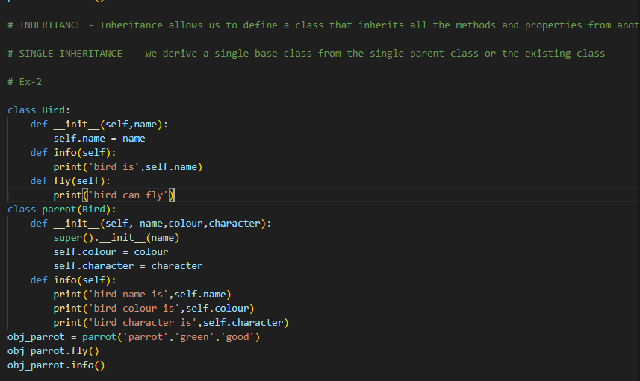 4. Hierarchial Inheritance

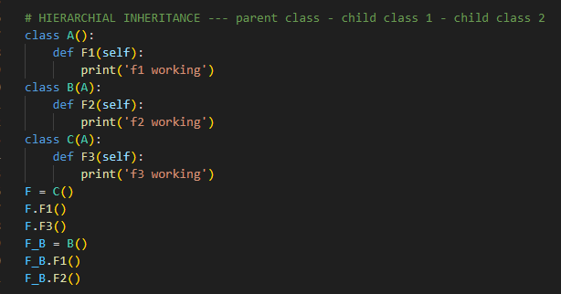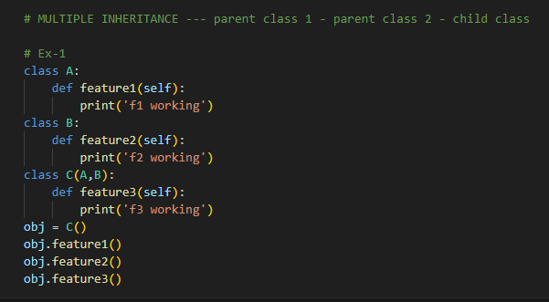

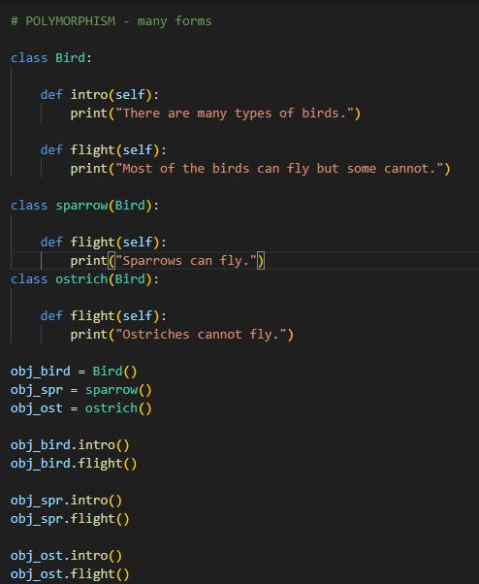**Polymorphism:**

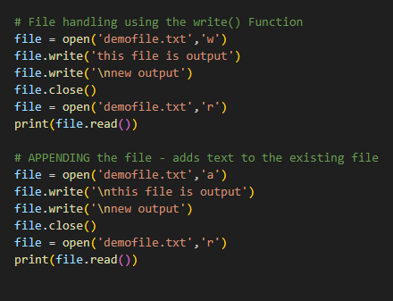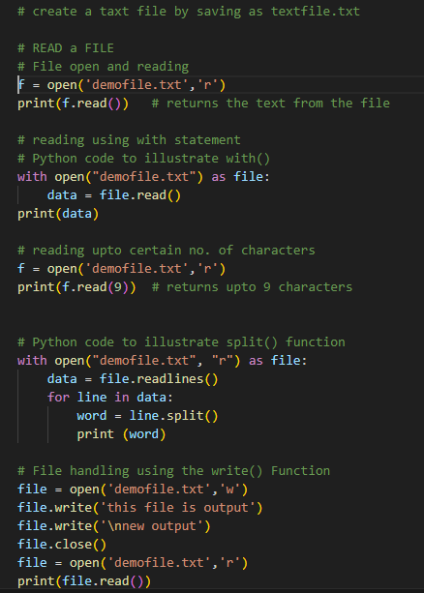**File Handling:**



**Try, Except & Finally:**

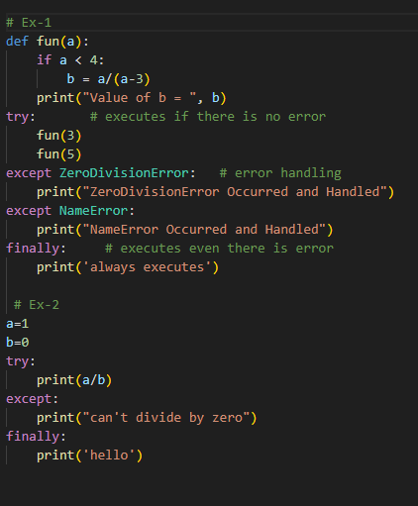

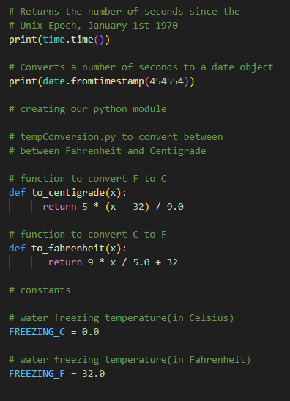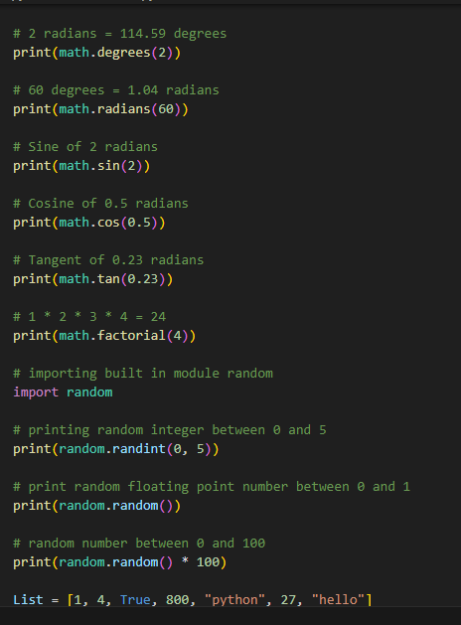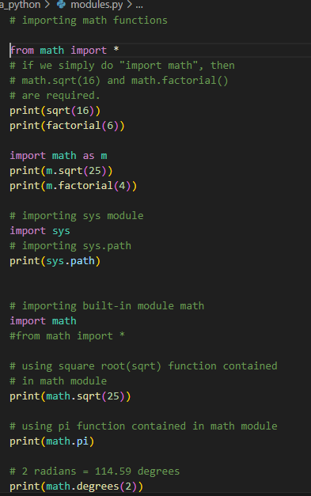**Modules:**